MEMT 201 HW #9 – Brittle Fracture

1. You have an aluminum alloy plate with an internal crack. The plain strain fracture toughness of this material is 40 MPa-m-1/2. The critical stress for a 4.0 mm internal crack is 300 MPa. For a 6.0 mm crack, will fracture occur at a stress level of 260 MPa?

If K > K_{IC} (40 MPa-√m), then fracture occurs.

Find K:

K = yσ√(πa)

Find y:

a := 4 mm / 2 = 0.002 m

Y = K_{IC} / (σ√(πa)) := 40 / (300 √(π * 0.002)) = 1.68

Plug Y:

A := 6 mm / 2 = 0.003 m

K := 1.68 * (260) * √(π * 0.003) = 42.4 MPa-√m

42.4 MPa-√m = K > K_{IC} = 40 MPa-√m, so fracture occurs.

2. You have the following table of Charpy Impact Test data.

Temperature (deg C) | Impact Energy (J)
0 | 105
-25 | 104
-50 | 103
-75 | 97
-100 | 63
-113 | 40
-125 | 34
-150 | 28
-175 | 25
-200 | 24

a.) Plot the Impact Energy vs. Temperature
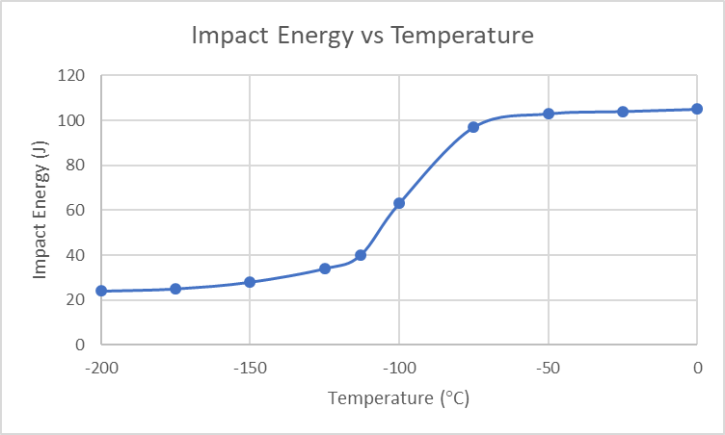

b.) Find the DBTT as related to the average of the maximum and the minimum impact
fracture energies.

Temperature of highest impact energy, T_{max} := 0 °C
Temperature of lowest impact energy, T_{min} := -200 °C

Average Temperature T := -100 °C

c.) Find the DBTT as related to an impact energy level of 30 J.

According to the graph above:
The temperature corresponding to an impact energy of 30 Joules, T :≈ -140 °C

